Docker complete Step by step process

1)Create a VM on ec2 instance

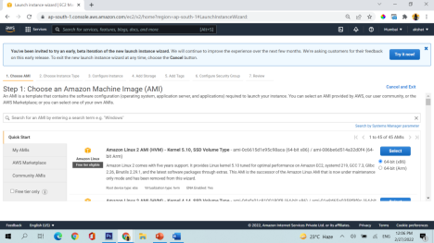Select amazon linux 2 ami

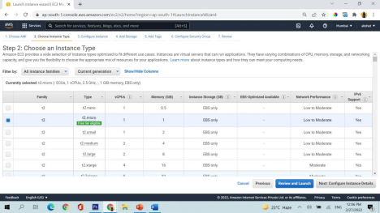Select t2.micro and configure instance details

Add storage

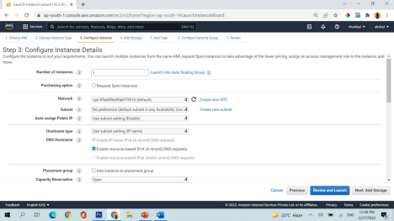

Add tags

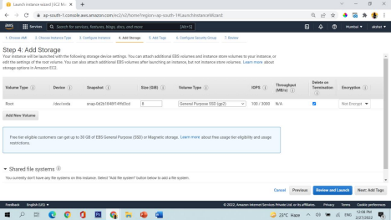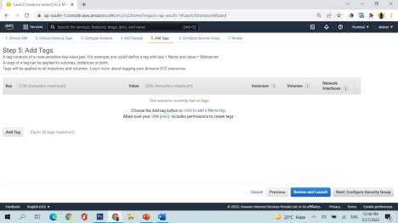Configure security groups

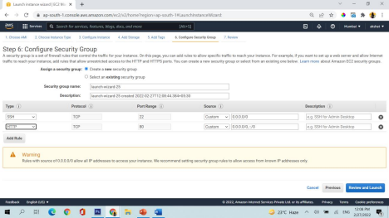Add http and review and launch

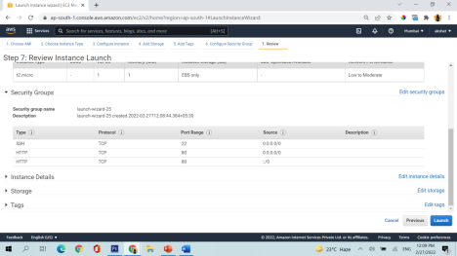Now launch

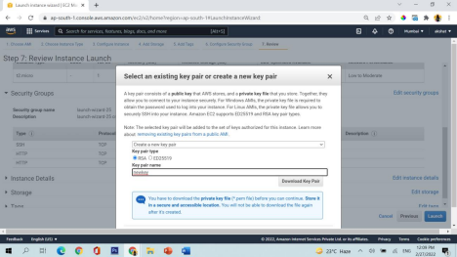Create a new keypair and download it

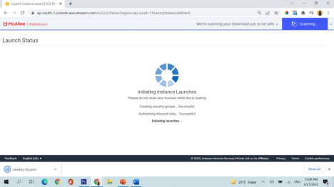launch instance

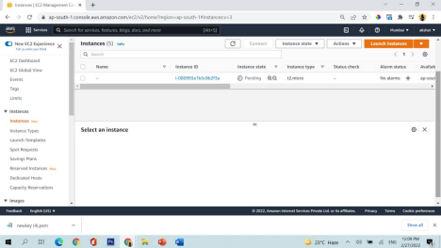See instance is created in pending state

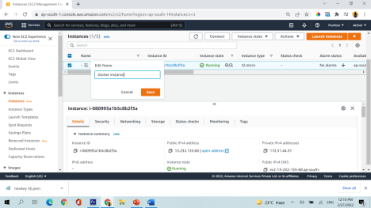give the instance (virtual machine) a name

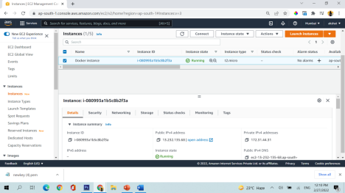Wait for 4-5 mins for machine to go live properly

**2)Connection with the instance (Virtual machine)**

Download a software mobaxterm

(https://drive.google.com/file/d/1y

kG7FmY55jaDYa4IbrHbzSLlSHNbodG/view?usp=sharing) from here

It will look like this

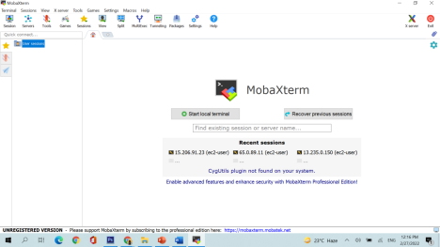

Now click on session and start a new session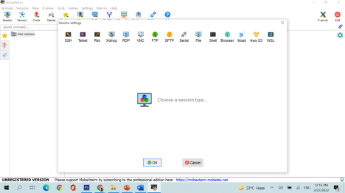

Go to ssh and in remote host put public ip of the machine and tick mark specify username and put ec2-user there

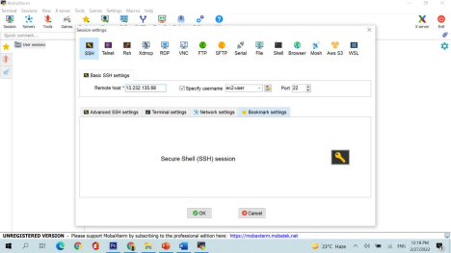

From here you will get the public ip of the machine

Click on Advance ssh setting in mobaxterm

And select use private key and select the key which you have downloaded while creating machine



Successfully connected



3)Now put these commands in the machine ➢sudo su

➢yum install docker -y (this will install docker in your machine)

➢yum update -y (update all the softwares in your machine)

➢which docker (tells you the location where docker is installed)

➢ docker - - version (tells you the docker version installed in your linux machine)

➢ ➢service docker status

➢service docker start (start docker in your machine) ➢docker images

➢docker ps (shows which all dockers are running) ➢ docker ps -a (shows which all dockers are created)

4)Now go to google chrome



Search ubuntu

Click on ubuntu https://hub.docker.com/_/ubuntu

➢docker run -it ubuntu /bin/bash (put you inside the docker container)

➢ls

➢cat /etc/os-release (here the output would be ubuntu)

➢exit (stop and exit from container)

➢docker images

➢docker run-it ubuntu /bin/bash

➢ exit

➢docker ps -a

➢docker ps

➢docker start <<name of the docker which you will get from docker ps -a command>>